Hedge Fund_Final Exam – Review Notes
Date: 21 March 2026

To-Study
1)
The Evolution of Hedge Fund Research
Lectures by Professor Narayan Naik
Mathias Kruttli∗
July 2013
2)
slide covers the flagship fund and risk-return characteristics🫠
flagship fund in the context of understanding index and benchmarks.
3)
I noted the following related to the exam:
1. Data. Describe the data. What do you see? What's missing in the database? What can change.
2. Benchmark - difference between index and benchmark. What's the meaning of a flagship fund? Case study on index - what kind of rebalancing etc. What kind of finds are in the index, who is putting this together. Classification.
3. Share restrictions. Redemption conditions.
4. Incentives. Compensation. How often reset high water mark (HWM)? Hurdles. Performance fees.
5. Strategy risk factors. Go through slide on "risk return characteristics".
- Essay based questions. Easy to pass, slightly difficult to excel. Half page answers per question are good enough. Maxm 2 pages
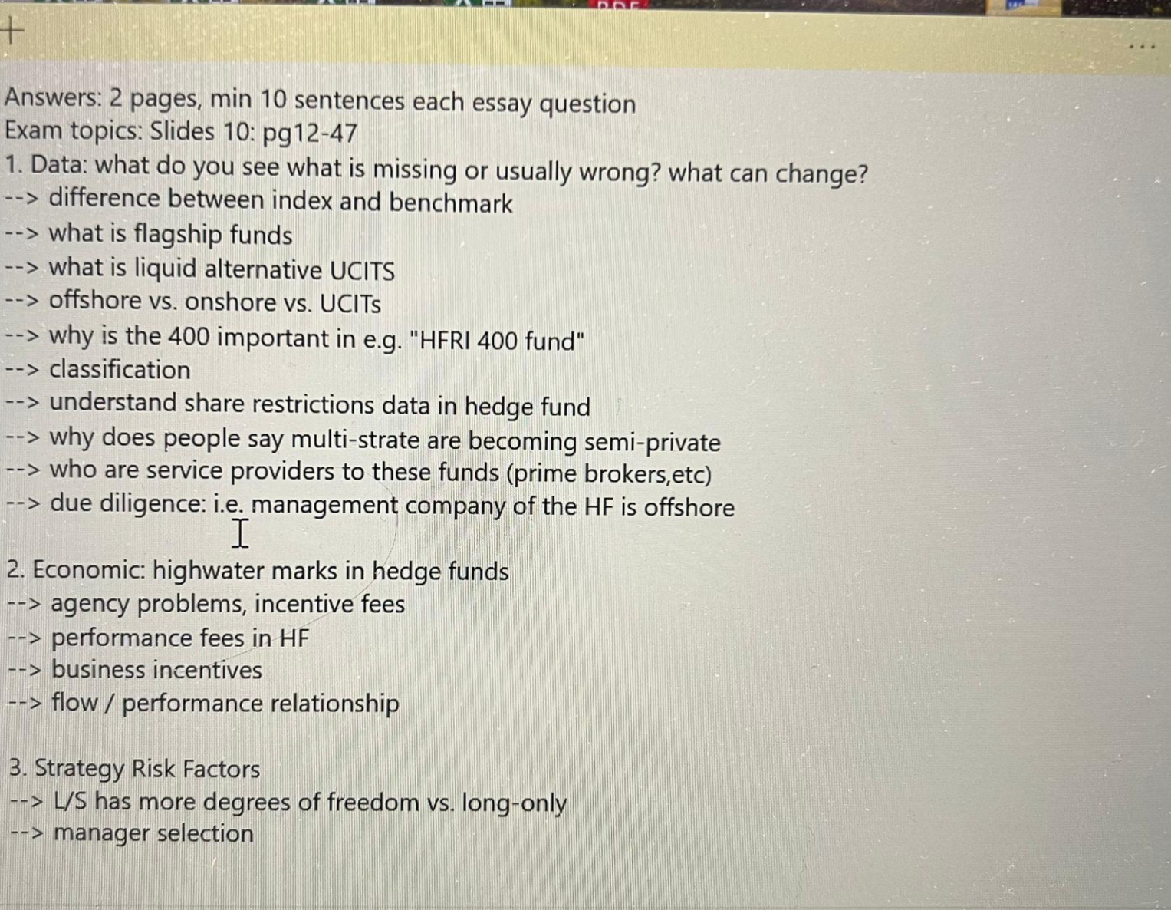

Class Review
Session 1
Guest Speaker: Keith Dalrymple, Dalrymple Finance

Exam Review
- Data
- Describe the Data
- What do you see in the data?
- What's missing in the database?
- What’s usually wrong in the Data?
- What can change in the Data?

Review Slides Review

1.
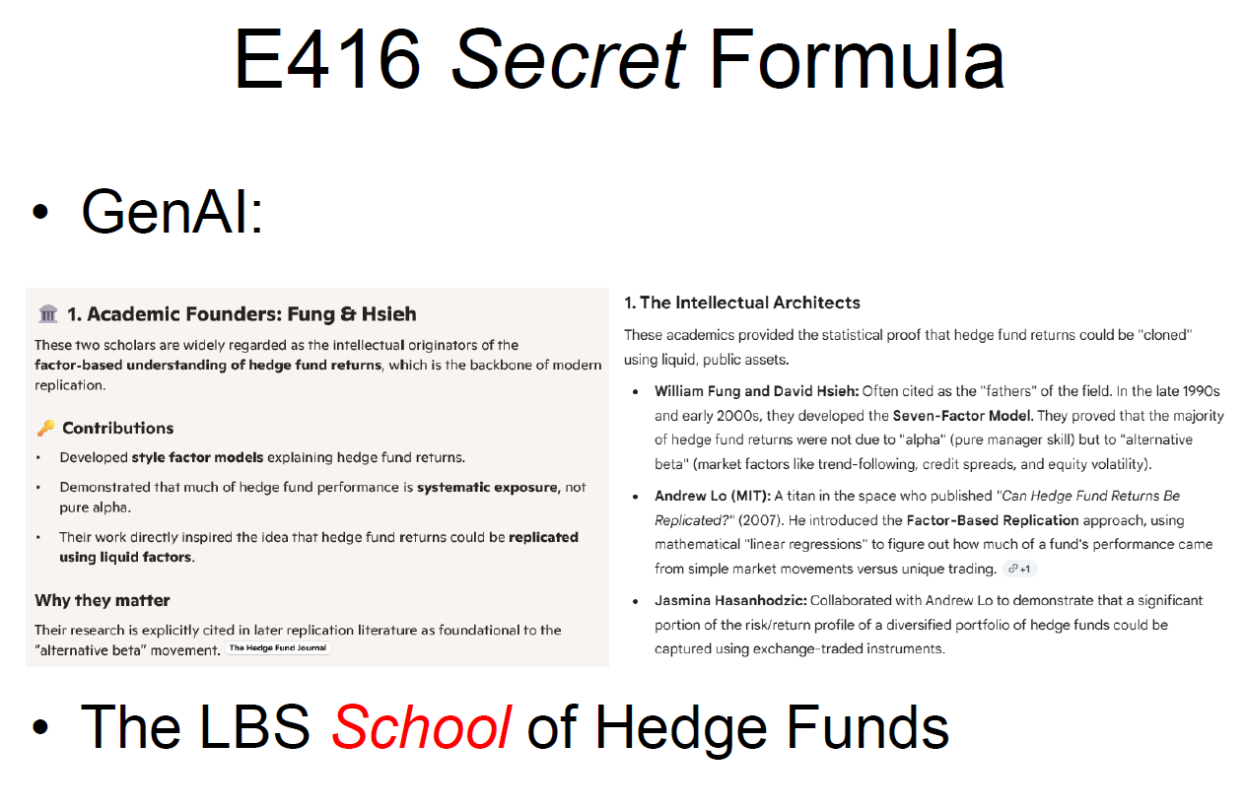
Factor-based understanding of Hedge Fund returns
1.1 Who Founded Hedge Fund Replication Theory?
Hedge fund replication theory does not have a single “founder,” but emerged from two major intellectual lineages: (1) academic factor-based modeling of hedge fund returns, and (2) practitioner-driven alternative beta research. The key early figures include William Fung & David Hsieh, Lars Jaeger, and later Nils Tuchschmid, Erik Wallerstein, and Sassan Zaker as formalizers of replication methodologies. [Link: https://thehedgefundjournal.com/replication-of-hedge-fund-strategies/]
Key Takeaways: Replication of Hedge Fund Strategies, thehedgefundjournal.com [Originally published in the March 2007 issue]
- Discussion on alpha vs beta
The discussion on alpha versus beta in the breakdown of investment returns is as old as the capital asset pricing model which defined these terms about 40 years ago. The discussion has finally reached the hedge fund industry, an area of investing traditionally associated with ‘pure alpha’ and therefore often referred to as driven by absolute returns, and debate on sources of hedge fund returns has started to change the landscape of hedge fund investing. Academic research and investors alike have begun to realise that also for hedge funds the ‘search for alpha’ must begin with the ‘understanding of beta’.

Hedge fund beta is often very different from traditional beta. While both are the result of exposures to systematic risks in the global capital markets, beta in hedge fund investing can be significantly more complex than traditional beta. We shall therefore refer to this beta as hedge fund beta, or synonymously alternative beta.

The extraction of the latter requires non-conventional techniques such as short selling, leverage and the use of derivatives; techniques which are often directly used to characterise hedge funds. Examples of alternative betas extracted by hedge funds include various equity style factors (small cap versus large cap, value versus growth, momentum), event risk premiums, exposure to volatility (Vega risk), commercial hedging demand premiums in the global futures markets, and various types of spread positions such as those employed in FX and interest rate carry strategies.

Several product providers have recently announced their intention to launch so-called passive hedge fund products or, as they have more recently been referred to, ‘hedge fund clones’. The underlying claim is that we can represent hedge fund-like returns at significantly lower fee levels to the investors. In fact, a new buzzword is out: hedge fund replication.

Where did the alpha go?
There is good reason to believe that the average alpha extracted by hedge fund managers is destined to decline. As a matter of fact, we can already observe today that alpha has decreased in recent years. Independent of our research, diminishing alpha has been observed elsewhere and Fung et al report on this same phenomenon in one of their later research papers. Will the alpha in hedge funds disappear entirely? Probably not, but it will certainly become harder to identify and isolate in the growing jungle of hedge funds.

📊 Link to your article (important concept)
The article on hedge fund replication argues:
- If alpha is declining…
- And many returns come from systematic exposures (beta)…
👉 Then investors might:
- Replicate hedge fund returns cheaply (using factor models)
- Avoid paying high fees (2 & 20)

💡 One-line exam answer
The paragraph argues that increasing competition and market efficiency are reducing the average alpha generated by hedge funds, making true skill-based returns rarer and harder to identify, though not completely disappearing.

Why hedge fund replication is attractive: The charm of saving fees
The beauty of beta – be it traditional or alternative – is that it can be systematically described, modelled and – replicated! And the biggest attraction in replicating hedge fund return profiles is simply described: fees. If beta (in alternative form) accounts for 80% of hedge fund returns and savings of 2% management fee and 20% performance fee can be achieved on these returns, approximately 2.5 to 3.5% pa of total fees can be eliminated compared to a fund of funds. Furthermore, the investor saves an additional ‘fee level’ avoiding asymmetric performance fees charged in a fund of fund’s portfolio. Our estimates for this additional fee layer range from 0.4% to 0.8% per annum. Financing costs for leverage represent a third, even less transparent, additional fee level that replication strategies avoid by trading futures and options on margin. We can summarise that replication approaches potentially offer significant fee savings of around 350-575 bps pa, an advantage that conventional managers of broad hedge fund portfolios will find it hard to compete with.

Linear factor models and where they fail
The basic approach to modelling alternative betas follows along the lines of the various asset pricing models in standard finance. Indeed, a growing amount of academic literature on (linear) systematic risk factors and hedge funds’ exposure to these exists by now. However, the quality of the offered models differs strongly for different hedge fund styles. In other words, the underlying factor models for the different strategy sectors offer a variable degree of explanatory power for hedge fund returns. While long/short equity has been well modelled in academic research, models for strategies such as arbitrage strategies (equity market neutral, convertible arbitrage) display rather limited explanatory power (ie low R-squared values in linear factor models).

Many of the recently announced efforts on ‘passive hedge fund replication’ are based in one form or another on these linear factor models. However, such a ‘passive’ hedge fund investing approach has well-known pitfalls and limitations:
- Hedge fund exposure cannot be conclusively described in a stationary linear modelling context. In fact, we see plenty of evidence confirming that significant deviations from the linear risk exposures are typical for hedge funds. Where do the non-linear profiles in hedge funds come from?
a. Hedge funds contain contingent payout profiles, imposed either explicitly through the inclusion of options into a typical hedge fund portfolio, or implicitly through managers employing conditional rule-based trading strategies.
b. The beta exposure of hedge funds is not stationary. Most hedge fund strategies involve active trading in response to opportunities and changing market environments. In other words, hedge fund managers react dynamically to changing market conditions with shifts in their exposure profile.
- Factor models are based on past data only. In contrast, hedge fund managers base their decisions on more recent and current data and developments in the financial markets. Consequently, linear factor models bear a significant time lag in adjusting their risk exposures. Replicating hedge funds based on estimating the parameters of the linear regression factors relying on past data is similar to driving a car and only looking into the rear mirror.
- A systematic (and even passive) approach to modelling and investing into individual hedge fund strategies leaves the problem of asset allocation across the different strategy sectors wide open. Quite simply, a passive method of creating an optimal hedge fund allocation does not exist, due to the fact that there is no market proxy for the global hedge fund industry. The process of asset allocation is one of the key elements of added value of a portfolio manager and is active by its very nature.
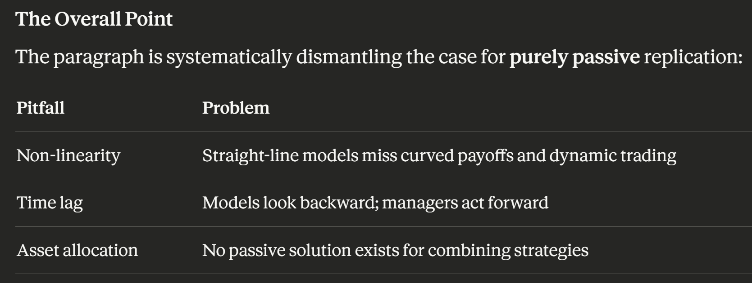
The article isn't saying replication is useless — it's saying naive, passive, linear replication is fundamentally inadequate. What's needed is a smarter, more dynamic approach. That's what the rest of the article likely builds toward.

We are of the opinion that the various passive hedge fund products that have recently emerged should be discussed in light of these points.

The path to full hedge fund replication: how can we overcome the first challenge? By explicitly including the non-linear and contingent return profiles of hedge funds! This sounds simpler than it actually is in practice: the inclusion of non-linearity in the models results in far greater mathematical intricacies. There are two methods of executing this task:

- The explicit incorporation of options into the model.
- The development of rule-based models of hedge fund strategies which implicitly consider the non-linear exposure.

We prefer the second route as it allows a more flexible adaptation to the dynamic nature of hedge fund strategies. For this we need to establish a set of transparent, rule-based strategies that mimic the hedge fund strategies and their (non-linear) risk exposures. This approach is by no means new, and the authors claim no intellectual property rights in this regard. In fact, to our knowledge, the idea of using strategy replications to model hedge fund returns was first developed in a 2001 academic paper by Fung and Hsieh for managed futures strategies, wherein the authors modelled the performance of a generic trend-following strategy using look-back straddle options. Since that date, they and others have applied this type of modelling to a variety of other hedge fund styles including merger arbitrage, fixed income arbitrage, and long/short equity. In most of these studies the employed trading strategies generally reached a good correspondence with the performance of the respective hedge fund strategy sector.
[The Key Insight for Your Exam]
The distinction being drawn is:
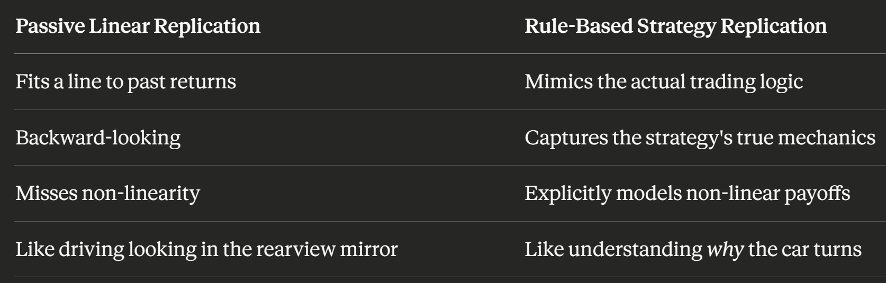
The punchline is that good replication requires understanding what a strategy actually does, not just what its historical returns looked like. That's a much more powerful and honest approach.

[Further]

🏛️ 1. Academic Founders: Fung & Hsieh
These two scholars are widely regarded as the intellectual originators of the factor-based understanding of hedge fund returns, which is the backbone of modern replication.
🔑 Contributions
- Developed style factor models explaining hedge fund returns.
- Demonstrated that much of hedge fund performance is systematic exposure, not pure alpha.
- Their work directly inspired the idea that hedge fund returns could be replicated using liquid factors.
Why they matter
Their research is explicitly cited in later replication literature as foundational to the “alternative beta” movement.

🧪 2. Practitioner Founder: Dr. Lars Jaeger (Partners Group)
Lars Jaeger is the most prominent practitioner associated with formalizing and popularizing hedge fund replication in the mid-2000s.
🔑 Contributions
- Coined and promoted the concept of “alternative beta”.
- Argued that hedge fund returns could be decomposed and replicated using systematic exposures.
- Published widely and influenced the launch of early hedge fund clone products on Wall Street.

Why he matters
Jaeger is often considered the public face of hedge fund replication during its commercial emergence.

📘 3. Formalization in Quantitative Finance: Tuchschmid, Wallerstein & Zaker
These authors contributed the most comprehensive academic treatment of replication methods in The Oxford Handbook of Quantitative Asset Management.
🔑 Contributions
- Classified replication into three canonical approaches:
  - Factor replication (top-down)
  - Rule-based replication (bottom-up)
  - Dynamic trading replication (distributional matching)
- Provided rigorous frameworks for algorithmic replication.

Why they matter
They systematized the field and provided the taxonomy still used today.

🧩 4. Additional Intellectual Roots
While not “founders,” several strands of research fed into replication theory:
Mechanical / strategy-based replication
- Emerged from qualitative analysis of what hedge fund managers actually do (e.g., merger arb, CTA trend following).
Trading strategy indices
- Banks developed systematic trading indices as liquid alternatives to hedge funds, further pushing replication concepts.

Summary Table: Key Figures in Hedge Fund Replication Theory
Contributor | Role | Key Contribution
William Fung & David Hsieh | Academic founders | Style-factor models; decomposition of hedge fund returns into systematic exposures
Dr. Lars Jaeger | Practitioner founder | Popularized “alternative beta”; drove early hedge fund clone products
Tuchschmid, Wallerstein & Zaker | Formalizers | Defined the three replication approaches; academic codification
Investment banks (mid-2000s) | Commercializers | Launched early replication products and trading strategy indices

1. The Intellectual Architects
These academics provided the statistical proof that hedge fund returns could be “cloned” using liquid, public assets.
- William Fung and David Hsieh:
Often cited as the “fathers” of the field. In the late 1990s and early 2000s, they developed the Seven-Factor Model. They proved that the majority of hedge fund returns were not due to “alpha” (pure manager skill) but to “alternative beta” (market factors like trend-following, credit spreads, and equity volatility).
- Andrew Lo (MIT):
A titan in the space who published “Can Hedge Fund Returns Be Replicated?” (2007). He introduced the Factor-Based Replication approach, using mathematical linear regressions to figure out how much of a fund's performance came from simple market movements versus unique trading.
- Jasmina Hasanhodzic:
Collaborated with Andrew Lo to demonstrate that a significant portion of the risk/return profile of a diversified portfolio of hedge funds could be captured using exchange-traded instruments.

Below is a clear, evidence-based overview of the founders and intellectual origins of hedge fund replication theory, drawing directly from the most authoritative sources available.
🧠 Who Founded Hedge Fund Replication Theory?
Hedge fund replication theory ^{#1.1} does not have a single “founder,” but emerged from two major intellectual lineages: (1) academic factor-based modeling of hedge fund returns, and (2) practitioner-driven alternative beta research. The key early figures include William Fung & David Hsieh, Lars Jaeger, and later Nils Tuchschmid, Erik Wallerstein, and Sassan Zaker as formalizers of replication methodologies.
🏛️ 1. Academic Founders: Fung & Hsieh
These two scholars are widely regarded as the intellectual originators of the factor-based understanding of hedge fund returns, which is the backbone of modern replication.
🔑 Contributions
- Developed style factor models explaining hedge fund returns.
- Demonstrated that much of hedge fund performance is systematic exposure, not pure alpha.
- Their work directly inspired the idea that hedge fund returns could be replicated using liquid factors.
Why they matter
Their research is explicitly cited in later replication literature as foundational to the “alternative beta” movement.
🧪 2. Practitioner Founder: Dr. Lars Jaeger (Partners Group)
Lars Jaeger is the most prominent practitioner associated with formalizing and popularizing hedge fund replication in the mid-2000s.
🔑 Contributions
- Coined and promoted the concept of “alternative beta”.
- Argued that hedge fund returns could be decomposed and replicated using systematic exposures.
- Published widely and influenced the launch of early hedge fund clone products on Wall Street.
Why he matters
Jaeger is often considered the public face of hedge fund replication during its commercial emergence.
📘 3. Formalization in Quantitative Finance: Tuchschmid, Wallerstein & Zaker
These authors contributed the most comprehensive academic treatment of replication methods in The Oxford Handbook of Quantitative Asset Management.
🔑 Contributions
- Classified replication into three canonical approaches:
  - Factor replication (top-down)
  - Rule-based replication (bottom-up)
  - Dynamic trading replication (distributional matching)
- Provided rigorous frameworks for algorithmic replication.
Why they matter
They systematized the field and provided the taxonomy still used today.
🧩 4. Additional Intellectual Roots
While not “founders,” several strands of research fed into replication theory:
Mechanical / strategy-based replication
- Emerged from qualitative analysis of what hedge fund managers actually do (e.g., merger arb, CTA trend following).
Trading strategy indices
- Banks developed systematic trading indices as liquid alternatives to hedge funds, further pushing replication concepts.
🧱 Summary Table: Key Figures in Hedge Fund Replication Theory
Contributor | Role | Key Contribution
William Fung & David Hsieh | Academic founders | Style-factor models; decomposition of hedge fund returns into systematic exposures
Dr. Lars Jaeger | Practitioner founder | Popularized “alternative beta”; drove early hedge fund clone products
Tuchschmid, Wallerstein & Zaker | Formalizers | Defined the three replication approaches; academic codification
Investment banks (mid-2000s) | Commercializers | Launched early replication products and trading strategy indices
🔍 If you want, I can also map:
- The timeline of replication theory (1997 → 2007 → 2012 → today)
- The mathematical foundations (factor regressions, Kalman filters, dynamic replication)
- The major replication products launched by banks (GS, Merrill, JPM, Société Générale)
- How replication compares to liquid alternatives and multi-strategy funds
Just tell me which angle you want to explore next.

#1.1 What is Hedge Fund Replication Theory?
Hedge fund replication theory is the idea that you can reproduce the returns of hedge funds using transparent, liquid, rules-based strategies—instead of paying hedge funds high fees for the same exposures.
Think of it as asking:
“If hedge funds mostly earn returns from systematic factors, can we copy those factors cheaply and transparently?”
Replication theory says yes, at least for a large portion of hedge fund performance.
🔍 Why Would Anyone Want to Replicate Hedge Funds?
There are three big reasons, and they’re surprisingly practical.
1. 💸 Hedge funds are extremely expensive
Typical hedge fund fees:
- 2% management fee
- 20% performance fee
Replication strategies often cost 0.5% or less.
If you can get similar returns with a fraction of the cost, that’s a compelling proposition.
2. 🔒 Hedge funds are opaque and illiquid
Hedge funds don’t disclose:
- their positions
- their leverage
- their risk exposures
- their trading rules
Replication uses liquid instruments (futures, ETFs, swaps) and transparent rules, so investors get:
- daily liquidity
- clear risk exposures
- no lockups
This is especially attractive to institutions that need liquidity (pensions, endowments, insurers).
3. 📉 Most hedge fund returns come from systematic factors
This is the core insight from the academic research.
Many hedge fund strategies—especially macro, CTA, equity long/short, event-driven—derive returns from:
- market beta
- value
- momentum
- carry
- volatility selling
- trend following ^{#1.1.1}
If these exposures can be identified, they can be replicated mechanically.
Replication theory argues:
▲Hedge funds are not magical. They are bundles of alternative betas.
And alternative betas can be reproduced.
🧪 How Does Replication Actually Work?
There are three main approaches:
1. Factor-based (top-down)
Use statistical models to estimate what factors drive hedge fund returns, then recreate those exposures.
2. Rule-based (bottom-up)
Rebuild the strategy itself (e.g., trend following, merger arbitrage) using transparent rules.
3. Distributional / dynamic replication
Use derivatives to match the payoff distribution of hedge funds.
Each approach has strengths and weaknesses, but all aim to deliver hedge-fund-like returns without hedge-fund-like costs.
🧱 So What’s the Point?
In one sentence:
Hedge fund replication exists because investors want hedge-fund-style returns, but without the fees, opacity, and illiquidity of actual hedge funds.
It’s not about replacing the very best hedge funds. It’s about replacing the average hedge fund—because the average hedge fund is expensive beta in disguise.
If you want, I can also break down:
- the math behind replication
- which hedge fund strategies are easiest/hardest to replicate
- whether replication actually works in practice
- how banks build replication products
Just tell me where you want to go next.

#1.1.1 Absolutely — these six “return sources” are the building blocks of many hedge fund strategies. Once you understand them, hedge fund behavior becomes much less mysterious.

I’ll break each one down in a way that’s intuitive, concrete, and connected to how hedge funds actually make money.
📈 1. Market Beta
What it is:
The return you get simply from being exposed to the overall market.

- If you own stocks, you have equity beta.
- If you own bonds, you have interest‑rate beta.

Why it matters:
Many hedge funds (especially equity long/short) secretly earn a lot of their returns just by being long the market, even if they claim to be “market neutral.”

Example:
If the S&P 500 rises 10% and a hedge fund rises 8%, a big chunk of that 8% may just be beta.

💎 2. Value
What it is:
Buying cheap assets and selling expensive ones.
- Cheap = low price relative to earnings, cash flow, book value, etc.
- Expensive = high price relative to fundamentals.

Why hedge funds use it:
Value has historically delivered long‑term excess returns because markets overreact to bad news.

Example:
Long undervalued banks, short overpriced tech stocks.

⚡ 3. Momentum
What it is:
Buying assets that have been going up and selling assets that have been going down.

Why it works:
Markets tend to trend because investors underreact to new information.

Example:
If crude oil has been rising for 6 months, a momentum strategy might go long crude futures.

Hedge fund connection:
Trend‑following CTAs (Commodity Trading Advisors) are basically momentum machines.

💰 4. Carry
What it is:
- Earning the yield or income from holding an asset.

Carry exists everywhere:
- FX carry: Borrow in low‑interest currencies, invest in high‑interest currencies.
- Bond carry: Earn yield from higher‑yielding bonds.
- Equity carry: Dividends.
- Volatility carry: Selling options and collecting premium.

Why it works:
Investors demand extra return for holding “risky” income streams.

Example:
Long emerging‑market bonds (high yield), short U.S. Treasuries (low yield).

🌪️ 5. Volatility Selling
What it is:
- Selling insurance against market moves — usually by selling options.
[Q: What if I want to profit when the market moves a lot? How can I trade with options?]

When you sell options, you collect premium.
If markets stay calm, you keep the premium.

Why hedge funds do it:
- Volatility is often overpriced because investors fear crashes.

Example:
Selling S&P 500 put options every month.

Risk:
This strategy makes small steady gains… until a big market crash wipes out months or years of profits.

📉 6. Trend Following
What it is:
- A systematic strategy that buys assets going up and sells assets going down — across many markets.

It’s momentum, but applied:
- across asset classes
- with strict rules
- often using futures

Why it works:
Markets exhibit long, persistent trends driven by macro cycles, central banks, and investor herding.
Example:
A CTA might be:
- Long gold
- Short Japanese yen
- Long U.S. equities
- Short natural gas
…all based on multi‑month price trends.

🧩 Why These Six Matter
These six return sources are the “alternative betas” that explain a huge portion of hedge fund performance.

Most hedge funds are not generating mysterious alpha.
They are combining:
- market exposure
- value
- momentum
- carry
- volatility premia
- trend following

…in different proportions.

Replication theory says:
If we can identify these exposures, we can rebuild them cheaply and transparently.

Review Slides Review
#2
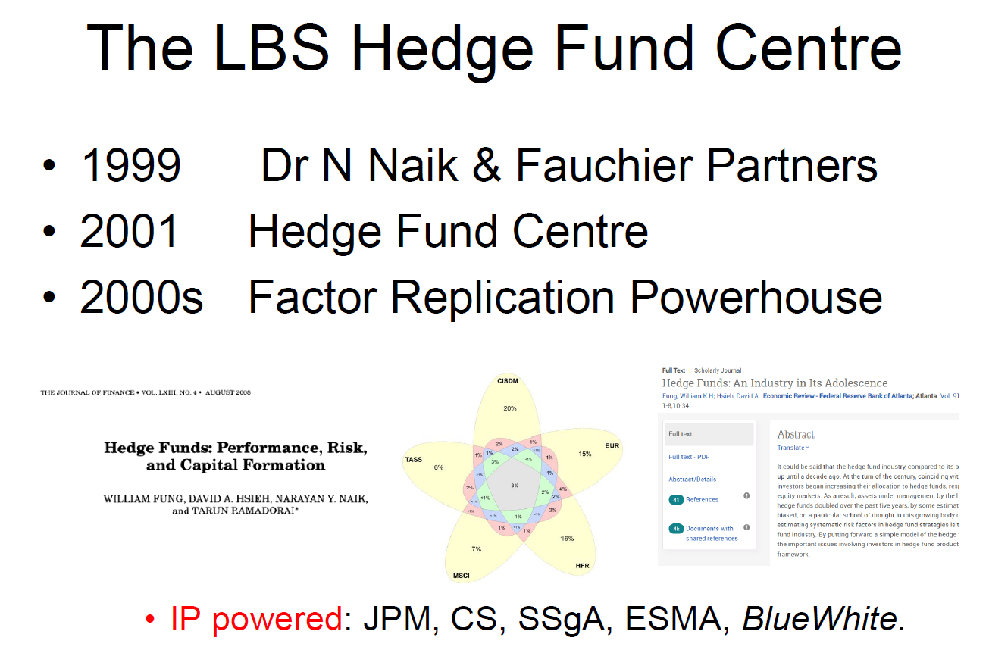
The LBS Hedge Fund Centre
- 1999 — Dr N. Naik & Fauchier Partners
- 2001 — Hedge Fund Centre
- 2000s — Factor Replication Powerhouse

Hedge Funds: An Industry in Its Adolescence (Fung, William K H ; Hsieh, David A. Economic Review - Federal Reserve Bank of Atlanta)
https://www.proquest.com/docview/200415719/fulltext/A2F564BA8D3F46FCPQ/1?accountid=16482&sourcetype=Scholarly%20Journals

🏢 Industry Adoption
- IP powered:
  - JPMorgan Chase
  - Credit Suisse
  - State Street Global Advisors
  - European Securities and Markets Authority
  - BlueWhite

#3.1
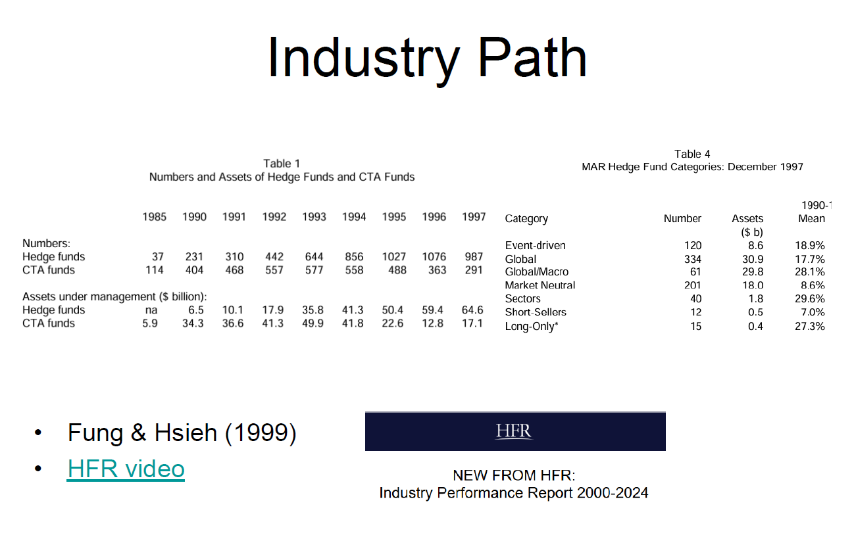
Summary of the Slide (Paragraph Form)
{Fung & Hsieh (1999)}
In Fung & Hsieh paper “A premier on hedge funds”, it illustrates the evolution of the hedge fund industry from 1985 to 1997, highlighting rapid growth in both the number of funds and assets under management (AUM). Hedge funds expanded significantly, increasing from 37 funds in 1985 to a peak of 1,076 in 1996 before slightly declining to 987 in 1997. In contrast, CTA (Commodity Trading Advisor) funds initially grew (from 114 to a peak of 488) but then declined in number after the mid-1990s. In terms of assets under management, hedge funds experienced strong and consistent growth, rising from negligible levels (6.5 billion) in 1990 to $64.6 billion by 1997, while CTA AUM fluctuated more erratically. This explosive growth reflects the increasing institutionalization of alternative investing through the 1990s.

In table 4, it also presents a breakdown of hedge fund strategies as of December 1997, showing that “Global” funds were the largest by number (334) and assets ($30.9 billion), while “Global/Macro” despite being fewer in number (61) had strong assets ($29.8 billion) and the second-highest mean return of 28.1% from 1990 onward. “Event-driven” and “Market Neutral” strategies also represent significant portions of the industry. Performance data from 1990–1997 indicates that strategies such as Global/Macro, Sector funds, and Long-Only funds delivered relatively high average returns (around 27–29%), while Market Neutral and Short-Selling strategies produced lower returns (Market Neutral: 8.6% while Short-Selling: 7%). Overall, the paper demonstrates both the rapid institutionalization of hedge funds and the diversification of strategies, setting the foundation for modern hedge fund industry structure.

#3.2
HFR Data, Video & Industry Performance Report
  - Video (https://www.youtube.com/watch?v=TvnBg3yGKYo)
- The hfr industry performance report analyzes hedge fund performance against US equities from 2000 to
2024.
- In 2014. the HFRI fund weighted Composite Index achieved a gain of 9.83% making it the ninth highest performance year since 2000.
- But against the strong returns posted by the S&P 500 Composite Index net returns are negative 13.02% the composite index did exceed the risk-free rate by a healthy 4.44%.
- Non-directional strategies were impacted by elections interest rate uncertainty and geopolitics,
- The HFRI equity hedge index saw an impressive gain of 11.97% in absolute returns with an excess return over the risk-free rate of 6.49%.
- Event-driven, relative value arbitrage and macro strategies also did well in the uncertain economy last year. Each posting high absolute gains.
- For greater nuance and insight, go to the full hfri industry performance report available as a free download on our website.

#3.3https://www.hfr.com/media/market-commentary/global-hedge-fund-industry-capital-surges-past-historic-5-trillion-milestone/
GLOBAL HEDGE FUND INDUSTRY CAPITAL SURGES PAST HISTORIC $5 TRILLION MILESTONE
HFRI records best annual performance since 2009
Industry capital grows by record $642.8 billion in 2025;
Healthcare funds drive Equity Hedge to lead HFRI strategy gains for the year
#3.4 HFRX Indices Mid-March 2026 Performance Update | HFR (Hedge Fund Research, Inc.) (https://www.youtube.com/watch?v=5t_V-4l7ipE&t=3s)
Welcome to HFRX mid-March performance update with Ken Hines. Financial markets hit a significant inflection point to begin March with a surge in volatility associated with the beginning of the military conflict. Oil prices surged over 40% in the first two weeks of the month with significant impact on equity markets which are sharply lower more so in emerging markets than developed. US interest
rates sharply higher, US dollar sharply higher, other metals commodities lower for the month. The uncertainty is significant and the hedge funds are navigating this volatile fluid situation with the sharpest areas of decline in directional equity hedge strategies as well as macro strategies which in the
first two months of the year had been strong performance. These have declined over 3% in the first two weeks of March.
So there's significant uncertainty and significant volatility in the financial market environment that hedge funds are navigating at this point.
Of the main strategies, relative value has seen the smallest loss of 99 basis points while market directional strategy index has declined 4% compared to US equities losing 2.5%. Year-to- date performance has been eroded by March
losses, but HFRX macro CTA is still up 2.2% compared to large cap equities,
which are down by the same percentage so far this year. Substrategy indices show equity market neutral and merger arbitrage down slightly by 53 and 85 basis points in March. Year-to-date performance in sub strategies shows macro systematic diversified holding up well with a 4% gain and equity hedge fundamental growth up 1.3% for the year so far. Get monthly index numbers by subscribing to our email updates at hfr.com and follow us on YouTube, LinkedIn, and X.

#4

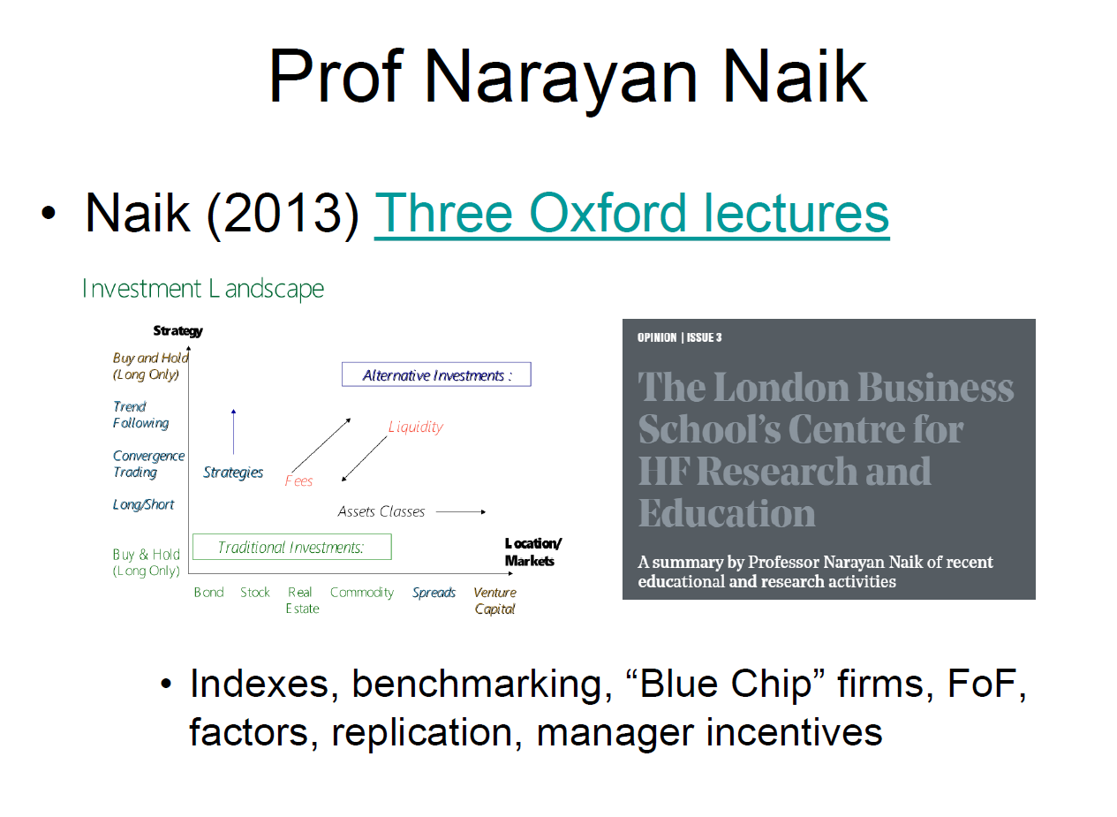

  - PDF -> Summary_Naik_Lecture_V2 (“The Evolution of Hedge Fund Research” Lectures by Professor Narayan Naik”)
  - https://thehedgefundjournal.com/the-london-business-school-s-centre-for-hf-research-and-education/

📝 The London Business School’s Centre for HF Research and Education
A summary by Professor Narayan Naik of recent educational and research activities
PROFESSOR NARAYAN NAIK
Originally published in the November 2004 issue

“It has been a busy couple of months at the Centre. We have just run another successful two-day course on hedge funds, of which more later, as well as publishing two more research papers.”

📊 Risk and Portfolio Decisions involving Hedge Funds
The first of the research documents, Risk and Portfolio Decisions involving Hedge Funds (working paper no. HF-009), argues that hedge funds, while compared with mutual funds, can follow more dynamic trading strategies, can take long as well as short positions and therefore can bet on spreads like the small-cap large-cap spread or the value-growth spread. As a result, hedge funds can offer exposure to risk factors that traditional “long-only” strategies cannot.
The key issue is to understand the kinds and nature of the risk factors associated with different hedge fund strategies. It shows that a wide range of equity-oriented hedge fund strategies exhibit a non-linear payoff structure resembling a short position in the put option on the equity market. They also show a significant exposure to the small-cap large-cap spread. Having documented the presence of non-linearities, the paper assesses its implications for portfolio construction. It argues that the traditional mean-variance framework ignores the presence of nonlinearities and shows how an alternative framework—Conditional Value-at-Risk (CVaR)—can be applied to construct hedge fund portfolios.
Finally, the paper also investigates how the limitations of the short history of hedge fund returns can be overcome by working with underlying risk factors estimated using a multi-factor model. Since the underlying assets have a longer history, this approach provides insights into the long-term risk-return trade-offs of hedge funds.
The paper starts by developing the theoretical framework for modelling non-linear payoffs in assets pricing and assigning a value to the skill of the manager generating non-linear payoffs. It illustrates the applicability of this approach by implementing it for equity-oriented hedge fund strategies. It uses hedge fund returns data from HFR and CSFB/Tremont databases. The paper estimates systematic risk factors of different hedge fund strategies and demonstrates its applicability using out of sample analysis. Next, the paper analyses portfolio decisions with hedge funds. After building the theoretical framework for Conditional Value at Risk (CVaR), it compares the tail-risk of mean-variance and mean-CVaR efficient portfolios. Finally, using the systematic risk factor model, it compares the long run performance of hedge funds with their recent performance.
The paper reaches three main findings. Firstly, the option-like payoffs are not limited to “trend followers” and “risk arbitragers”, but an integral feature of the payoffs on a wide range of hedge fund strategies. In particular, the payoffs on a large number of equity-oriented hedge fund strategies resemble those from writing a put option on the equity index.
Secondly, the analysis shows that the expected tail losses of mean-variance optimal portfolios could be underestimated by as high as 54% compared to mean-CVaR portfolios. This suggests that ignoring tail risk can result in significantly higher losses during large market downturns.
Finally, the extrapolation of hedge fund returns using underlying risk factors suggests that the hedge funds performance during the last decade is not representative of their long-term performance. In particular, the mean returns during the 1927–1989 period are significantly lower and their standard deviations are significantly higher compared to those of their recent performance.
The results of this paper demonstrate the importance of allowing non-linear risk return relation while analysing hedge funds. The findings are useful to investors and regulators as they can now better understand the risk-return characteristics of hedge funds. In addition, the analysis presents tools that can be used to measure the net and gross risk exposures of hedge funds and also to assist with hedge funds portfolio construction.

📊 Of flows, performance, and managerial incentives
Our second paper, Flows, Performance, and Managerial Incentives in Hedge Funds (working paper no. HF-016), discovers that hedge funds differ from mutual funds in a variety of aspects. They are less regulated, less transparent, charge performance-based compensation, and offer limited liquidity (lock-up, notice, and redemption periods) when compared to mutual funds. These differences have important implications for the incentives hedge fund managers have to deliver superior performance, as well as for the investment behaviour of investors. Using these issues as the basis, this paper investigates the complex relationship between flows, performance and managerial incentives in hedge funds.

The paper has two key objectives. Its first thrust is to analyse the determinants of money flows into hedge funds. In particular, its focus is on the relationship between money flows and past performance, managerial incentives, impediments to capital withdrawals, and past money flows. Its second objective is to analyse the relationship between fund size, past flows, managerial incentives, impediments to withdrawal and future performance.
The paper models the incentive-fee contract as a call option written by investors on assets under management. The net asset value (at which the money flows enter the fund), hurdle rate and high-water mark provisions determine the strike price of the call option. Since capital invested at different times are subjected to different high-water marks, the incentive-fee contract amounts to the manager holding a portfolio of call options with different strike prices.
The paper uses a comprehensive hedge fund database created by merging three large databases (namely HFR, TASS and ZCM/MAR). The database includes net returns, monthly assets under management, and other fund characteristics such as lock up and restriction periods, management and incentive fees, inception data and fund strategy. Using a multi-variate set up, it examines the relation between money flows, fund characteristics and past performance. For estimating the determinants of future performance, it regresses hedge fund returns against fund size, past flows, managerial incentives, and impediments to capital withdrawal (lock up and restriction periods).
The paper has four main findings relating to flows, past performance and managerial incentives. First, that money-flows chase returns and the relation between performance-flow is convex. Second, that money flows are significantly higher for consistent winners (and lower for consistent losers). Thirdly, there is a positive relationship between flows and managerial incentives. Finally, investors do not prefer impediments to capital withdrawals.
In addition, the paper revealed new findings regarding a fund’s future performance and its relationship to its size, past flows, managerial incentives, and lock up and restriction periods. It discovered that both the larger funds and the funds experiencing greater flows are associated with worse future performance, consistent with the presence of capacity constraint and decreasing returns to scale. It also documents a positive relationship between managerial incentives and future returns suggesting better incentives are associated with better future performance. Finally, the funds with greater impediments to withdrawal are often associated with better performance in the future, and this is consistent with investors earning a liquidity risk premium.
This work is currently being examined at a more macro level, which investigates whether money flows chase total returns or value added by the manager (the alpha). Preliminary analysis suggests that hedge fund investors do not distinguish between the alpha and beta-related components of total return. This has interesting implications for hedge fund managers’ response to the money flowing into hedge funds.

📦 Inside the Black Box
Last month the Centre successfully ran its popular two-day hedge fund course “Hedge Funds: Inside the Black-Box” for the sixth time in a row. As is frequently now the case, the participants on this course came from a wide range of backgrounds such as institutional and private investors, investment consultants, accountants, IFAs, trustees of pension funds and endowments, private bankers, managers of family offices and funds of hedge funds, hedge fund managers, risk managers, quantitative analysts, actuaries, regulators, lawyers, compliance officers and others.
This intensive course provides the knowledge and frameworks needed to address the key issues concerning hedge funds. Drawing on real-life cases, the course equips the participants with the practical tools and insights necessary to avoid common pitfalls. The enhanced understanding of the “what, why and how” of hedge funds and the economic intuition underlying various market practices is intended to transform the way graduates from the course deal with or manage hedge funds.

🧠 Amongst the questions the course tackles are:
- Why have hedge funds proved so attractive to some investors, while others remain wary?
- What is their performance record?
- How do hedge funds generate their returns?
- What kinds of risks do they take and how do these differ from traditional funds?
- How does capacity constraint affect hedge fund risks and returns?
- How important is qualitative analysis in fund selection and how useful is the past record?
- How does one think of a fund’s “alpha” and life cycle going forward, and when constructing a fund of hedge funds?
- Can “star” fund managers or prop-desk traders become successful hedge fund managers?
- What should investors look out for?
- How do regulators view hedge funds?
- Do hedge funds pose a systemic risk to the stability of financial markets?

The course starts with the basics of what the data does and doesn’t tell as well as the problems presented by hedge fund indices, but quickly moves on to models of investment returns – the traditional version versus the hedge funds, for example. It also highlights how hedge fund alphas differ from traditional fund alphas. One cannot examine alpha without first looking at the betas. The search of alpha really begins with the search for betas. It provides a unifying theory of hedge funds, a framework that can be consistently applied across a wide range of strategies. It analyses the investment behaviour of hedge fund investors and discusses the implications of chasing return winners in the presence of capacity constraints. Our course applies the insights obtained in the process of strategic asset allocation, portfolio construction and implementation, risk management, and performance evaluation of hedge funds.
In spite of having considerable prior knowledge of hedge funds and their investment styles, trading strategies, structures, and compensation methods, the participants frequently find the analysis compelling, thought-provoking and indispensable. The programme is run under the supervision of Professor Narayan Naik and his colleagues. This was a well-delivered programme – a good mix of case studies and analysis has helped identify gaps in my own knowledge and has raised my awareness of current thinking. I would strongly recommend the Hedge Funds Programme to others.
And Man’s Alison Carnwath said:
“The Hedge Funds Programme was both educational and thought-provoking. My knowledge has been extended and the programme has left me contemplating alternative ways of approaching the industry.”
For more information about the Centre and its educational and research activities, please visit:
www.london.edu/hedgefunds

Summary #4
Slide Summary
The slide references Professor Narayan Naik of London Business School, one of the leading academic researchers on hedge funds. It points to his 2013 Oxford lectures and his work through LBS's Centre for HF Research and Education.
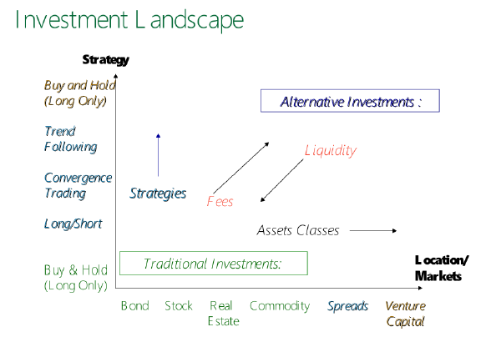
The Investment Landscape Diagram is the key visual. It maps the investment universe across two dimensions:
- Horizontal axis: Asset classes, ranging from traditional ones (bonds, stocks, real estate, commodities) on the left to more alternative ones (spreads, venture capital) on the right
- Vertical axis: Strategy type, ranging from simple buy-and-hold (long only) at the bottom to more sophisticated strategies (trend following, convergence trading, long/short) moving upward
The diagram draws a clear distinction between traditional investments (bottom left — buy and hold in standard asset classes) and alternative investments (top right — more complex strategies in less liquid, more exotic asset classes). The arrows pointing toward "fees" and "liquidity" suggest that as you move into alternative investments, you encounter higher fees and lower liquidity as the price of accessing those strategies. The core message is that hedge funds occupy the upper-right space — they use sophisticated strategies across a broad range of asset classes, and investors pay for that complexity through fees and illiquidity.
The bullet points at the bottom — indexes, benchmarking, "Blue Chip" firms, FoF, factors, replication, manager incentives — are essentially the entire research agenda of the hedge fund academic literature that Naik's work covers.
1. Slide Summary (Prof Narayan Naik)
🔑 What the slide is about
👉 It shows the evolution of the investment landscape from:
- Traditional investing → Alternative/hedge fund investing

📊 Chart Explanation (VERY IMPORTANT)
LEFT SIDE: Strategies
- Buy & Hold (Long Only) → traditional
- Trend Following
- Convergence Trading
- Long/Short
👉 As you go down:
- Strategies become more active & complex

BOTTOM: Asset Classes
- Bonds, Stocks, Real Estate, Commodities
👉 Traditional assets
Then:
- Spreads (e.g. arbitrage)
- Venture Capital
👉 Move toward alternative investments

RIGHT SIDE: Alternative Investments
- Hedge funds sit here:
  - More strategies
  - Less tied to traditional asset classes
  - Focus on relative value & trading

KEY AXES (interpretation)
1. Strategies ↑
- More sophisticated = more potential alpha
- But also harder to model/replicate
2. Assets Classes →
- Move from simple assets → complex exposures (spreads, derivatives)
3. Liquidity (diagonal)
- More alternative → less liquid
4. Fees
- Higher complexity → higher fees

🎯 Core Interpretation (EXAM GOLD)
Hedge funds are defined more by strategies than asset classes, and as you move toward alternative investments, you trade off liquidity and cost for potential alpha.

🧠 2. Naik (2013) – Three Oxford Lectures (Core Ideas)
🔑 Big Themes
1. Alpha vs Beta
- True alpha is rare
- Much of hedge fund returns = alternative beta

2. Factor Investing
- Returns driven by:
  - Trend-following
  - Credit
  - Equity
- These can be replicated

3. Capacity Constraints
- As funds grow:
  - Performance ↓
👉 Diseconomies of scale

4. Non-linearity
- Hedge fund returns:
  - Often option-like
  - Not captured by simple models

5. Investor Behaviour
- Investors:
  - Chase past returns
  - Don’t distinguish alpha vs beta

6. Manager Incentives
- Incentive fees = call option payoff
👉 Leads to:
- Risk-taking incentives

🧠 3. LBS Hedge Fund Centre – Key Takeaways
🔑 Core Contributions
1. Factor Replication
- Shows hedge fund returns can be:
👉 Decomposed + replicated

2. Non-linear Risk
- Hedge funds ≠ linear
- Need:
  - CVaR
  - Tail risk analysis

3. Portfolio Construction
- Mean-variance ❌ insufficient
- Must consider:
  - Tail risk
  - Non-linearity

4. Capital Flows & Incentives
- Flows:
  - Chase performance
  - Are convex
- Incentives:
  - Improve performance
  - But create risk-taking

5. Industry Insight
- Hedge funds:
  - Provide liquidity
  - Improve price discovery
- But:
  - Create systemic risk (via leverage)

Key Takeaways from Naik's Oxford Lectures
Lecture 1 — Assessing Manager Skill
The central question is whether hedge fund managers justify their 2-and-20 fees. Early literature used LIBOR + 3% as the benchmark. "Blue Chip" flagship hedge funds dramatically outperformed this — roughly tripling investor money from 2000–2010. However, the rest of the industry (non-flagship funds) struggled to even match LIBOR + 3%. This immediately raises the question: are most managers actually generating alpha, or just beta exposure dressed up expensively?
Naik argues that to properly assess alpha, you must account for alternative betas — risk factors specific to hedge funds like credit spreads and option-based trading strategies. The proper model separates returns into: true alpha + traditional beta exposure + alternative beta exposure. Managers whose returns are fully explained by these factors are not generating skill — they're just taking risk — and their returns can be replicated cheaply via indices.
Lecture 2 — Non-Linearity and Manager Incentives
Naik and Agarwal show that hedge fund returns have non-linear, option-like characteristics that standard linear models miss. They augment traditional factor models with option-based factors (buying/selling at-the-money and out-of-the-money options), achieving R-squared values of up to 92%. The implication is that hedge fund returns must be decomposed into a buy-and-hold component and a dynamic trading/options component. Crucially, this means standard VaR and mean-variance analysis underestimates tail risk in hedge funds — the left tail is much fatter than it appears.
On incentives, Naik identifies four pillars of proper hedge fund manager alignment: performance fees (~60% of total fees), high-water mark provisions, hurdle rates, and manager co-investment. These structures reduce the principal-agent problem, which is why hedge funds accept light regulation in exchange.

Reference Links
  - https://www.proquest.com/docview/200415719/fulltext/A2F564BA8D3F46FCPQ/1?accountid=16482&sourcetype=Scholarly%20Journals
  - https://thehedgefundjournal.com/replication-of-hedge-fund-strategies/
  - https://en.wikipedia.org/wiki/Hedge_fund_replication

PDFs
  - Summary_Naik_Lecture_V2 (“The Evolution of Hedge Fund Research Lectures by Professor Narayan Naik”)

